Human Reproduction Notes

I. The Male System
A. Parts:
- Testes - male gonads that contain ____________________________ that make
_____________ and ________________________that make testosterone.
- Scrotum – hold tests away from ______________________________________
____________________________________
- Epididymis – tubes on top of the testes ________________________________
_________________________________________________.
- Vas deferens - tubes that transfer sperm from the _______________________
to the ______________________
- Urethra - route for release of ______________________________________.
- Seminal vesicles, prostate gland, Cowper’s gland – _______________________
_______________________________
Jobs of fluid:
______________ provides energy for sperm’s trip
_____________________ protects sperm from acidity in vagina
Sperm + fluid = ___________________________.
Each ejaculate contains ___________________________________
- Penis - _____________________________________________

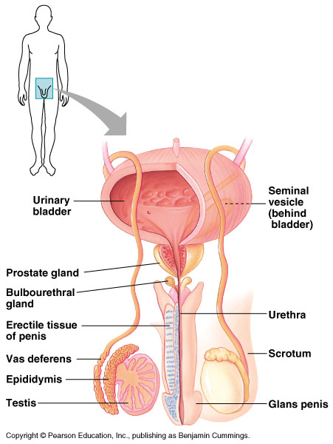
Cowper’s gland
B. Interesting Tidbits of Info.
- _____________________________ - the surgical removal of the foreskin, common in the US today but not in all countries. Some cultures don’t do this until puberty.
- _____________________________ - surgically cutting and tying the vas deferens to stop sperm from being released (prevents pregnancy). Fluids are still released during ejaculation.

C. Sperm
- Mature sperm contain:
a. A head containing ______________________
b. An _____________________________ at the front which is a sac filled with
________________to help the sperm ______________________________
_________________________
c. A tail to swim.
2. Only 1 sperm can enter and fertilize a single egg.
3. Men make around ________________ which totals about ___________________
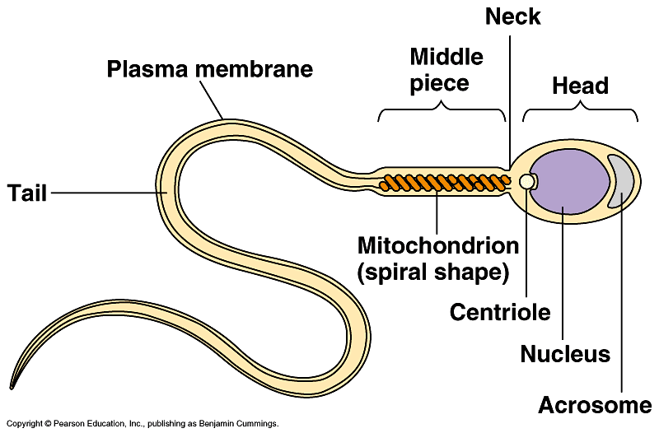
D. Male Hormones
- Testosterone is the main sex hormone in males. It gives males their secondary sexual characteristics and sex drive.
- Secondary sexual characteristics begin developing ______________________
________________________________
- Due to testosterone, males typically.. 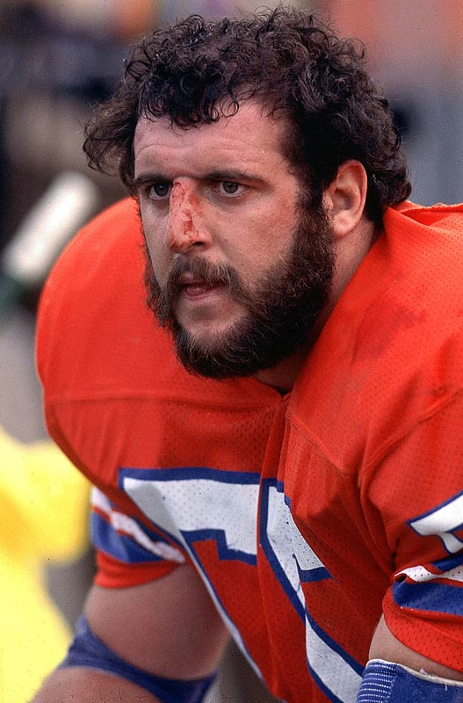
  - are taller than females: broad shoulders, long legs…
  - have deeper voices – associated with larger larynx (the Adam’s apple).
  - have more facial and body hair
  - have larger muscle mass
  - are more aggressive

II. The Female System
A. Parts:
- Ovaries - female gonads containing thousands of follicles that __________________
______________________________________.
- Follicles - tiny sacs insides ovaries, each storing ____________________________.
During ______________ a follicle breaks and releases egg. Women have around
400,000 eggs at birth.
- Oviducts (= the fallopian tubes) – 2 thin tubes that eggs travel in on their way to
the uterus. This is where _________________________________________.
- Uterus – a muscular organ where the _____________________________________
________________________
- Endometrium - _____________________________________________________
________________to accept fertilized egg.
- Cervix - narrow opening between the uterus and vagina that opens from __________
____________________________________________________________
- Vagina – serves as birth canal and exit for menstrual flow.
- Clitoris – external area of sexual stimulation in women.
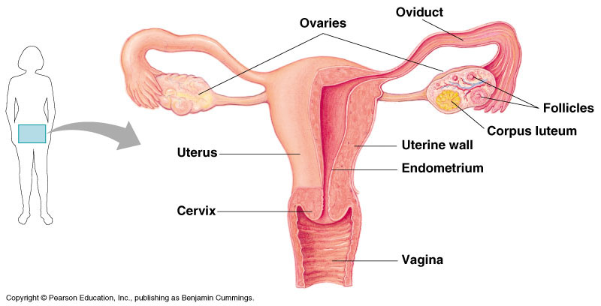

B. Interesting Tidbits of Info.
- A woman can get her __________________________to prevent pregnancy. This is a surgical procedure where the oviducts are cut to block the passage of eggs.
- ____________________________________ is performed in some cultures – this involves cutting off the clitoris at the start puberty to prevent a woman from feeling pleasure with sex. The belief is that she will then not be interested in having sex with anyone other than her husband. Many women are mutilated and/or die from this every year.
C. Female Hormones
- The ovaries produce 2 of the female hormones: _________________________
____________________________
- These hormones are what contribute to female secondary sexual characteristics:
  - body hair
  - wider hips and specific fat distribution
  - breast development
  - smooth skin


III. The Menstrual Cycle
A cycle of fertility that results in pregnancy or menstruation. Occurs in ___________
_________________________________.

General Characteristics
- The whole cycle lasts around ___________.
- Women begin menstruating around the age of ________ and continue until menopause around ____________
- Every step is controlled by the hormones _______________________________
__________________________________________

B. Details on the Cycle
- During the first 2 weeks one egg matures
- At the same time the ______________________________________________
- ready to ________________________________________________
- Around ___________ of the cycle ____________________________________
___________________. This is when a woman can ________________________
- If an egg is not fertilized ____________________________________________
________________________ which causes the endometrium to go into muscular
contractions causing _______________________________ (≈ day _______ ).
Typically lasts 5-7 days.
- Major hormonal changes and contractions cause ______________________________ – cramping, moodiness, digestive problems, headaches, fatigue, etc.

Menopause
Ending of ____________________________________________ in women around
________________ yrs. old. Ovaries stop responding to _________________
which leads to:
- loss of ability to _________________________
- __________________________________________
- dry skin and brittle hair
- _____________________ (osteoporosis), etc
Question:
Most species can reproduce throughout life, what is the evolutionary advantage to menopause in humans?

IV. Reproduction
- Fertilization
- One sperm meets one egg ________________________________
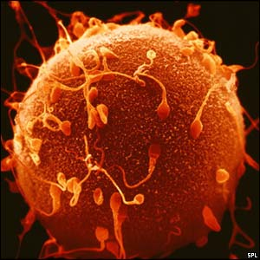
- The acrosome releases enzymes and 1 sperm breaks through the egg’s membrane
→ ___________________________________
___________________________________

- Sperm and egg nuclei join, creating a ___________________________________
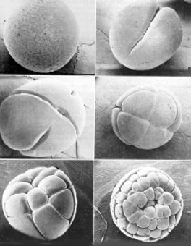
- A fertilized egg = ________________________. The zygote starts to divide as it moves to the uterus.
- The embryo implants into the endometrium several days after fertilization.
- The embryo secretes the ______________________________
(pregnancy tests detect HCG in urine). HCG helps ____________
________________________ during the 1st few months.

Twins
- If ____________________________________________________________
= non-identical (fraternal) twins.
- If ___________________________________________________, and the egg
splits as it starts to develop = _______________________________________
- If the egg starts to split but remains attached in a small spot = ________________
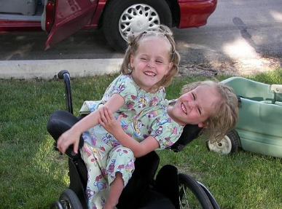
__________________

V. Forms of Birth Control
  - Abstinence - __________________________! The only 100% effective way to prevent pregnancy and STDs.
  - Birth control pills - ________________________________________________, preventing eggs from developing / or being released.
  - Condoms - latex or natural skin covering placed over the penis to prevent sperm from entering the vagina. ________________________________________________ ________________________________________________
  - Spermicide - chemicals that kill sperm on contact - works well when combined with other methods, but ________________________________________________
  - The Diaphragm - a _________________________________________________ to prevent sperm from entering the uterus. Often combined with spermicide. Very effective when positioned correctly, but ________________________________
________________________________________

